Project Name: Piggy Bank
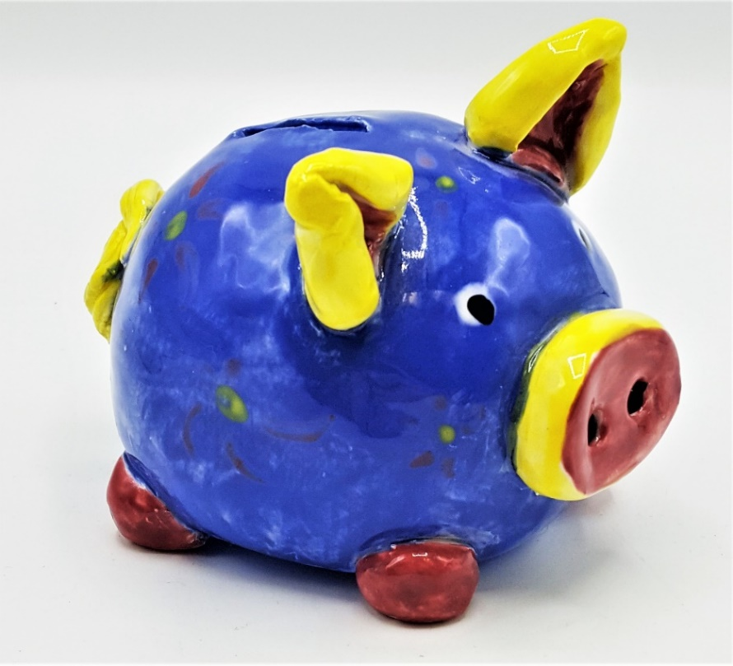
Objective: Sculpt a piggy bank out of clay
Number of lesson videos to complete project: 2
Supplies needed for this project:
- Clay
- Scratcher tool
- Wooden skewer
- Cup of water
- Paper towel
- Folded Newspaper Square

Step 1 – Pinch Pot Body
We’re going to start by making a pinch pot. This is exactly what it sounds like, a pot that we make by pinching. We’re going to pinch the larger ball of clay to create a small bowl. Stick your thumb into one of your the larger pieces of clay. Then use your other four fingers to pinch all the way around while turning it in your hand. Keep your fingers flat. Your fingers should be pinching as if you have a sock puppet on that is biting the clay. Your pot will get bigger and thinner. The walls should be the thickness of a chocolate chip cookie. Don’t make it too thin! Turn the ball and continue pinching all the way around until you have made a small bowl. Now set it on your newspaper, rim side down. We will need two pinch pots, so take your other large ball of clay and make another pinch pot the same size as your first. Next, tap each pot lightly on the table, rim facing down, to flatten the rims.
Step 2 – SCRATCH AND ATTACH!
We need to put our two pinch pots together to make a ball. Take your balled up newspaper and stick it inside one pinch pot. This will keep it from collapsing in on itself. To get them to properly stick together, we have to use a technique called “scratching and attaching”. Take your scratching tool and dip it into your water cup. Then apply scratches to the rims of both pinch pots. You need to make really good scratches! Not just lines, but deep and messy scratches, so that the clay will bond together. Then, firmly press the scratched areas together, assuring your halves stay together.
Step 3 – Smooth
Now we’re going to smooth out any lumps in the clay by using your finger. Try to get the line to disappear.
Step 4 – Eyes
Pull off two pieces of clay from your last ball for the eyes. Roll them into balls about the size of strawberries. Place the clay onto the table and press down with your palm to make the shape of a cookie. Do this to both pieces. You now have a set of eyes! Set them to the side.
Step 5 – The Ears
Pull off a piece of clay from your ball for the ears. Place the clay onto the table and press down with your palm and roll your hand overtop the clay so it will take the shape of a carrot. Once the piece is rolled out, cut it down the center long ways with your skewer. Use your fingers to smooth out the edges.
Step 6 – Small Parts
Pull off four small pieces of clay, the size of marbles, from your last ball. These will be the legs. Pull off another piece of clay to make the pig’s tale. Roll into a snake shape and then curl it. Set these parts to the side.
Step 7 – SCRATCH AND ATTACH!
Now we have to attach all of the parts to our pig. Remember, this is a required step! If you do not do this or don’t do it well enough, the pieces will fall off. So, just like before, take your scratching tool and dip it into your water cup. Then apply scratches to the parts and to your ball where the pieces will be connecting. You need to make really good scratches! Not just lines, but deep and messy scratches, so that the clay will bond together. Then, firmly press the scratched areas together, assuring your parts stay connected.
Step 8 – Cut the Coin Slot
Using your wooden skewer, cut a rectangular hole into the top of your pig. It should be large enough for a quarter to fit into it with a little extra room.

Step 9 – Finishing Touches
Take your wooden skewer and press any details you wish into the pig, such as pupils for the eyes. Add any other details to your piece, but don’t forget the most important one. Your name and teacher’s name on the inside of your pinch pot. Great Job!

